**ASSIGNMENT 1**

**EXPLORATION**

**NAME : ABISEKH M**

**ROLL NO: 921319106005**

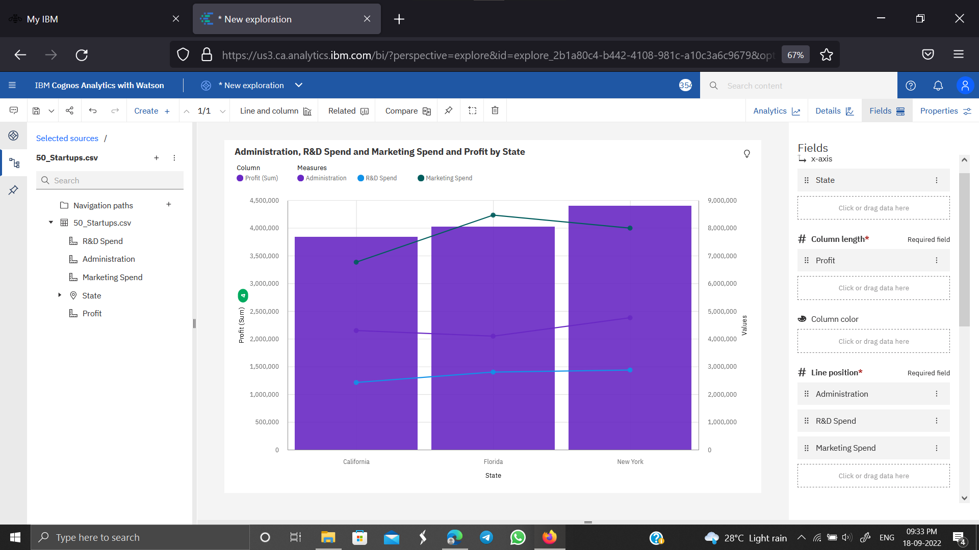**COLLEGE: PSNA COLLEGE OF ENGINEERING AND TECHNOLOGY**

1.LINES AND COLUMN

2.MARIMEKKO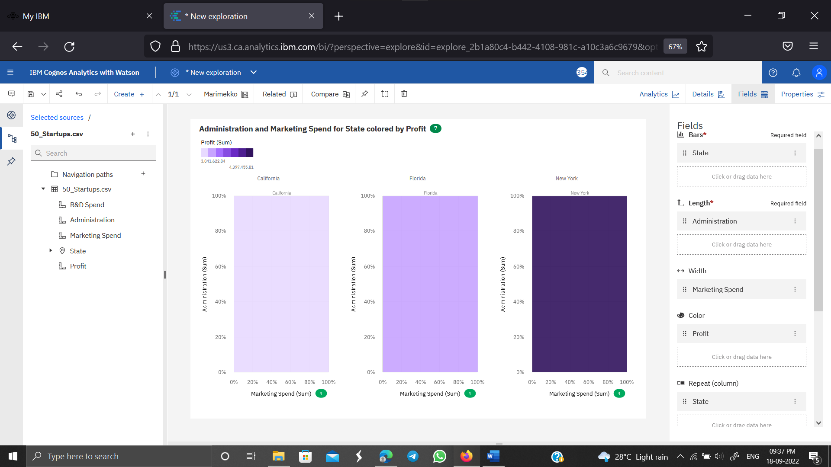

3.EXPLORATION WITH LINE GRAPH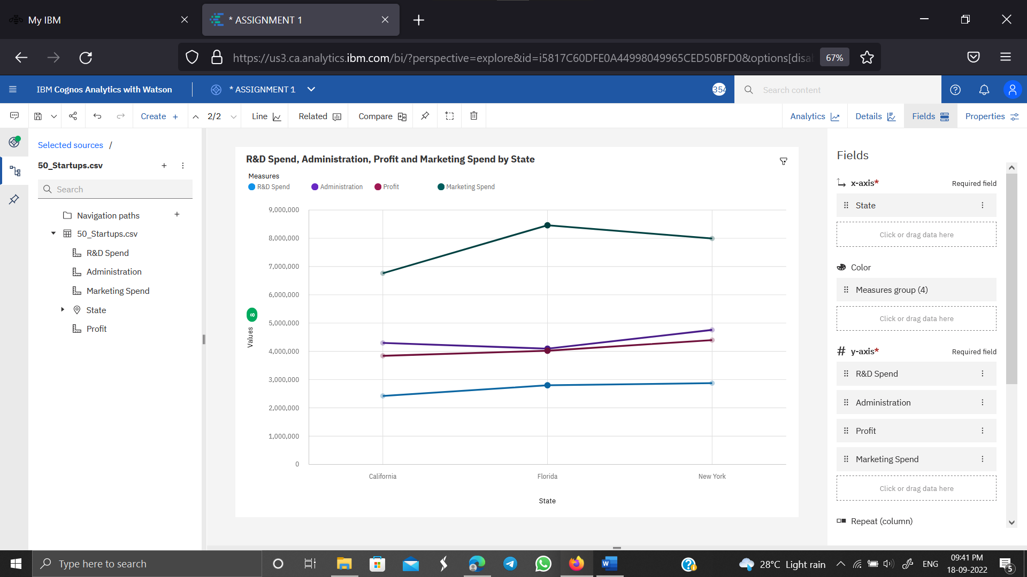

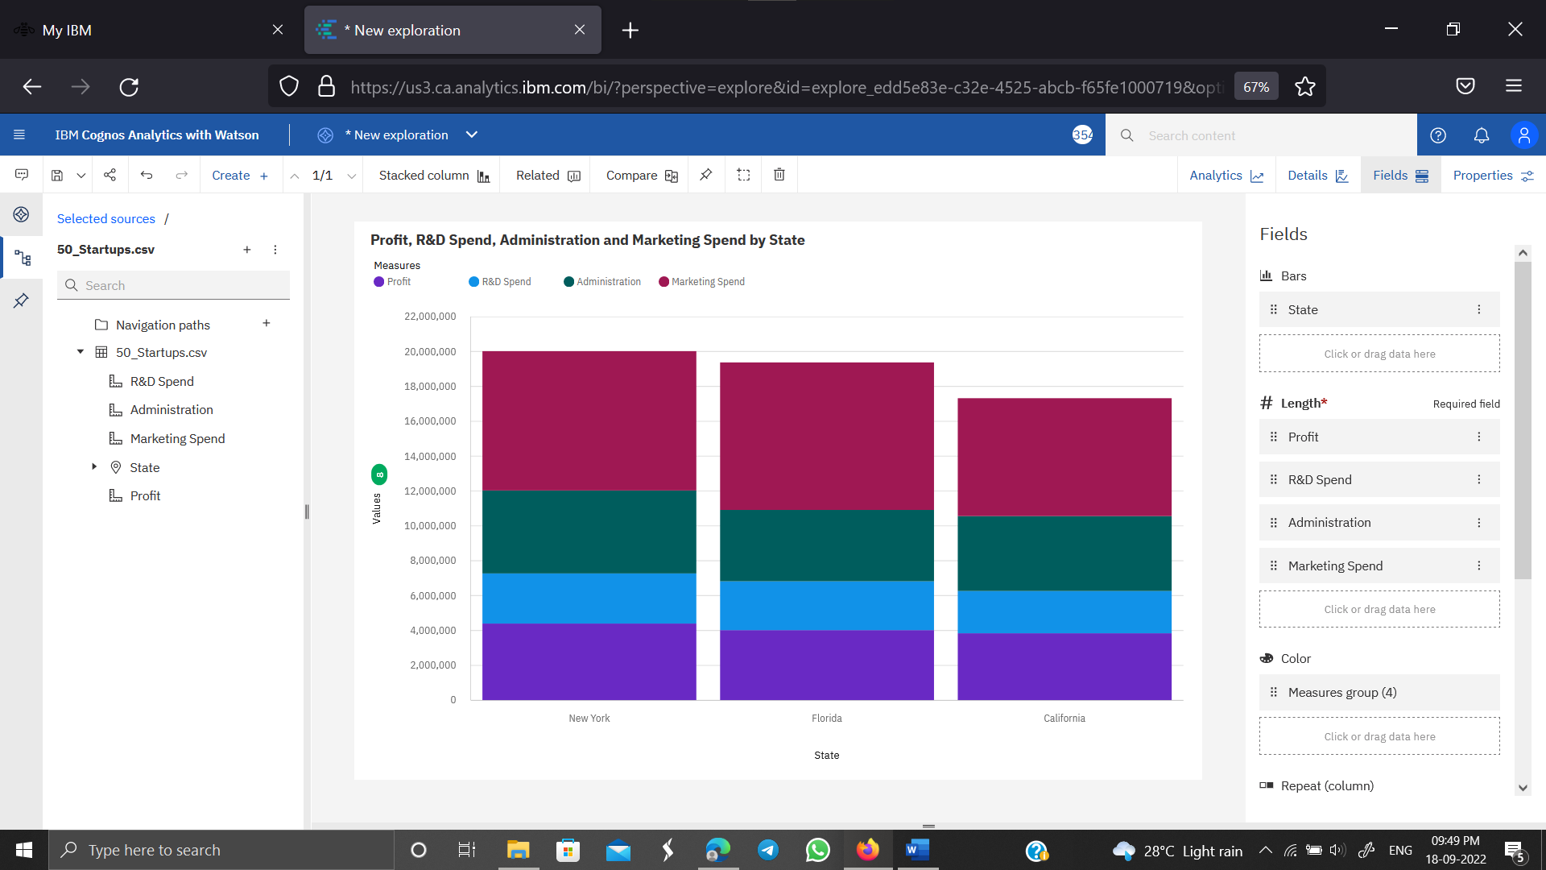**4. EXPLORATION WITH STACKED COLUMN**

**5.PIE CHART**

**USING STATE AND PROFIT**

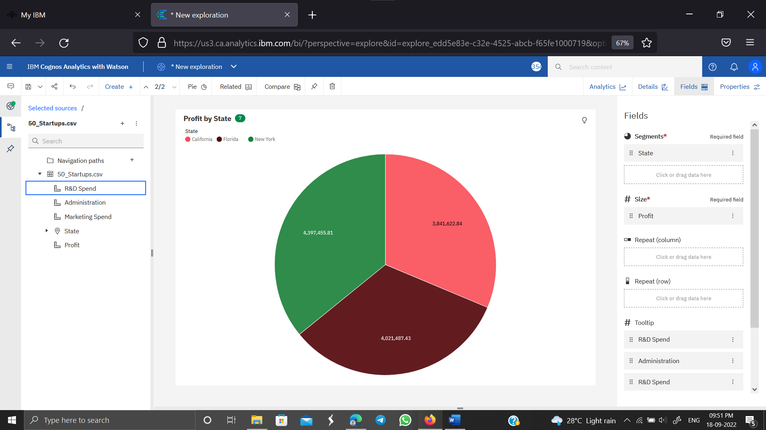

**6 EXPLORATION TABLE REPRESENTATION**

